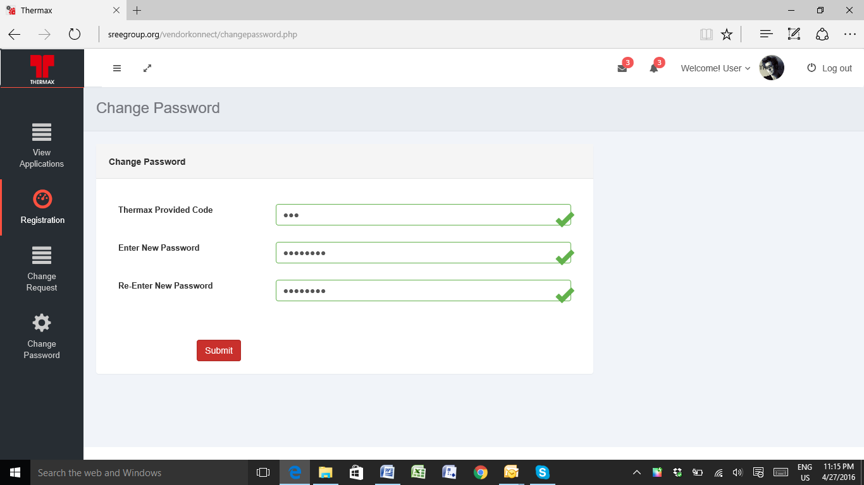

After change of password the screen is still there and not going to the home screen

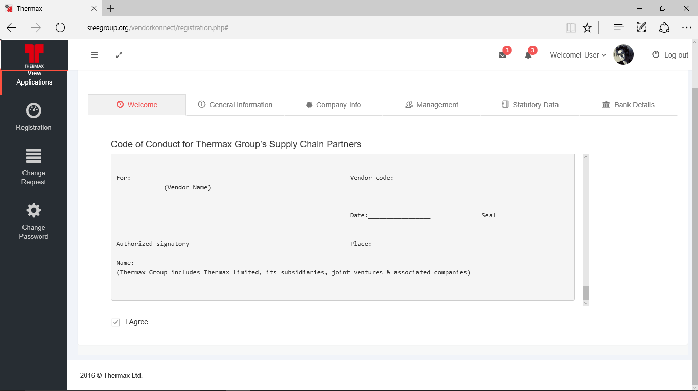

After reading the code of conduct the Vendor should download the same sign it and print it and upload back to the site.

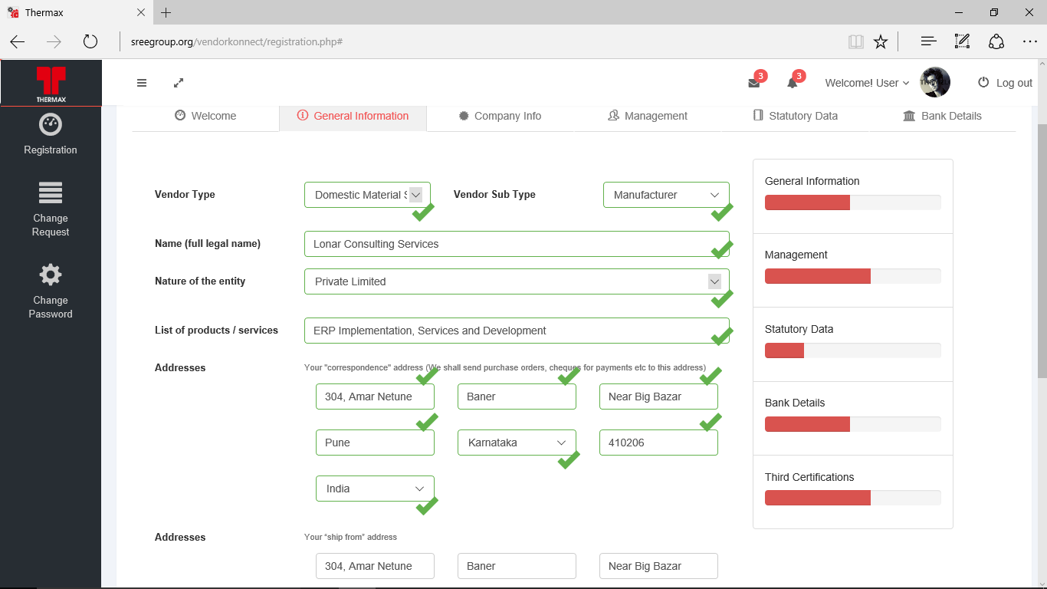

In “Ship from address” and Your “registered/principal office address” which ever country is selected Zimbawe is seen. After save the button should be disabled for further save unless there are any changes in the record so that the user will know the record is saved.

While loading the document the following error is happening

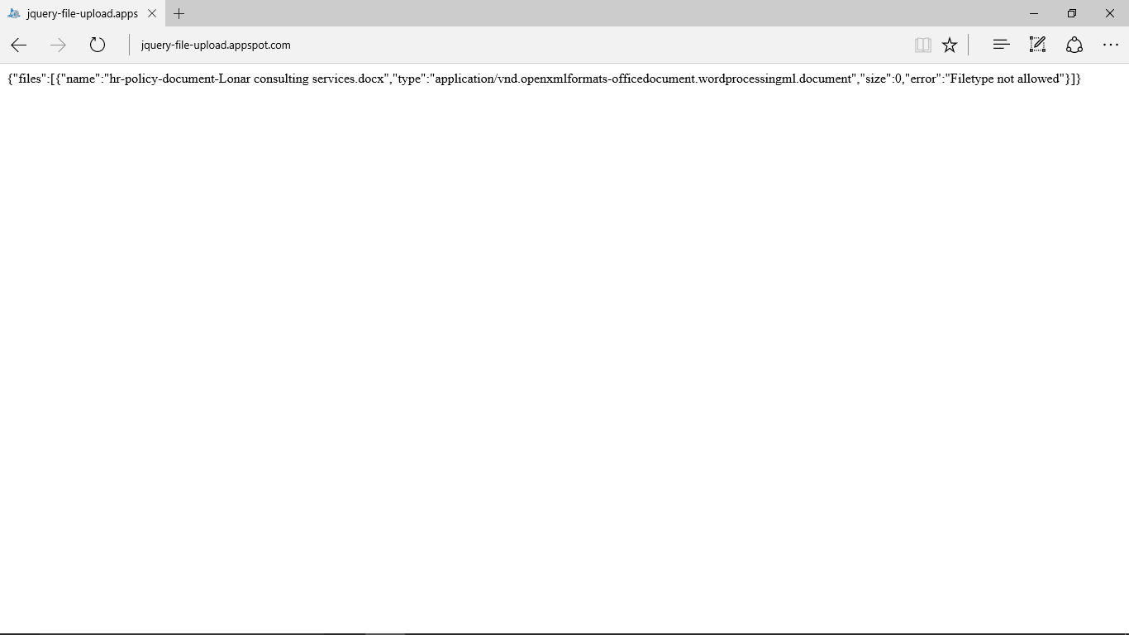

The List of document to be loaded is incomplete

Management information tab “Are any of your directors/ partners/ owners or relatives working/were working in THERMAX?” by default the option should be yes and place to enter the information has to be there.

For the Bank Details the IFSC code master is provided if it is choosen the Bank Name and the Brach details can automatically populate.

Without filling the IFSC code the information is seen in the summary data.